Friends and Workplaces Project

Bryn Loftness

**Understanding Your Relational Expectations.**

Researchers have found that people hold certain interaction expectations (prototypes) when determining the level of intimacy in a relationship.

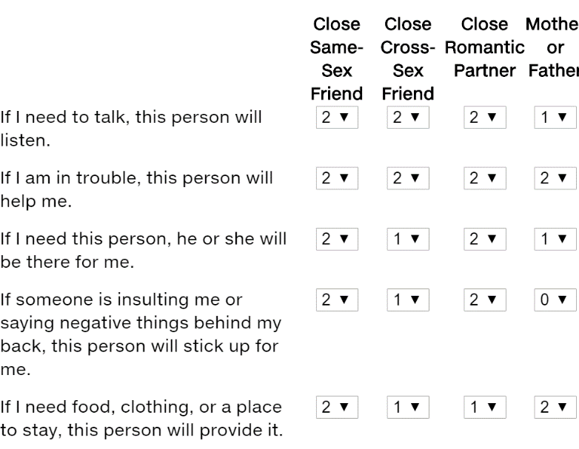From which of these people do you expect the most? From which of these people do you expect the least?

I expect the most of my Close Same-Sex Friend and my Father. Both of these people are usually the first I go to when I’m in trouble or if I need support; which I go to depends on the issue.

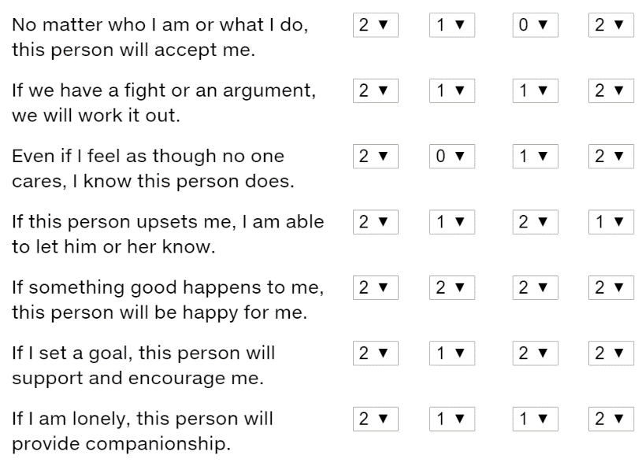I expect the least from my close cross-sex friend or my close romantic partner. I do go to them for support, but I expect the least. This could be a gender thing, I feel most comfortable confiding in other females or that I just don’t expect much from guys- my father being an exception of course.

**Preferences for Sharing Emotions.**

How comfortable are you expressing your emotions to others. Using a scale from 1 (least comfortable) to 10 (most comfortable), for each person, indicate how

comfortable you would be about sharing the following feelings:



• With whom are you most comfortable sharing your emotions?

I am most comfortable with “Close friend of the same sex”

• For those you are less comfortable sharing emotions with, what makes you uncomfortable about sharing certain emotions?

I am least comfortable with sharing emotions with an “Acquaintance of the opposite sex.” I think this is because you have a slightly more intimate relationship than a stranger but it’s on a very surface level. You haven’t gotten to the higher level of intimacy where you share more about yourself.

**Discovering Your Own Love Profile.**

The purpose of this assignment is for each student to

become aware of his or her attitude toward “love.” Project the following questions and ask

students to rate each statement on a Likert scale from 1 to 5:

1 = Strongly disagree

2 = Disagree

3 = Neutral

4 = Agree

5 = Strongly agree

1. 4 - You cannot love unless you have first had a caring relationship for a while.

2. 3 - The best kind of love grows out of a long friendship.

3. 3 - Kissing, cuddling, and sex should not be rushed into; they will happen naturally when

intimacy has grown.

4. 4 - Love is really deep friendship, not a mysterious, mystical emotion.

5. 2 - I believe that “love at first sight” is possible.

6. 3 - We kissed each other soon after we met because we both wanted to.

7. 5 - Usually the first thing that attracts my attention to a person is a pleasing appearance.

8. 4 - Strong physical attraction is one of the best things about being in love.

9. 4 - When things are not going right with us, my stomach gets upset.

10. 3 - Once when I thought a love affair was over, I saw him or her again and the old

feelings came surging back.

11. 2 - If my partner ignores me for a while, I sometimes do really stupid things to try to get

his or her attention.

12. 2 - When my partner does not pay attention to me, I feel sick all over.

13. 5 - I try to use my own strength to help my partner through difficult times, even when he

or she is behaving foolishly.

14. 2 - I am usually willing to sacrifice my own wishes in favor of my partner’s.

15. 3 - If my partner had a baby by someone else, I would want to raise it and care for it as if

it were my own.

16. 4 - I would rather break up with my partner than stand in his or her way.

17. 5 - For practical reasons, I would consider what he or she is going to become before I

commit myself.

18. 4 - You should plan your life before choosing a partner.

19. 2 - A main consideration in choosing a partner is how he or she reflects on my family.

20. 4 - I would not date anyone that I would not want to fall in love with.

21. 1 - At least once I had to plan carefully to keep two of my lovers from finding out about

each other.

22. 3 - I can get over love affairs pretty easily and quickly.

23. 2 - My partner would get upset if he or she knew some of the things I have done with

other people.

24. 3 - What he or she does not know about me will not hurt my partner.

Add your scores for statements 1–4. Divide by 4. This is your score for the friendship factor

(sturge). : **3.5**

Add your scores for statements 5–8. Divide by 4. This is your score for the passionate factor

(eros). : **3.5**

Add your scores for statements 9–12. Divide by 4. This is your score for the possessive factor

(mania). : **2.75**

Add your scores for statements 13–16. Divide by 4. This is your score for the selflessness

factor (agape). : **3.5**

Add your scores for statements 17–20. Divide by 4. This is your score for the practical factor

(pragma). : **3.75**

Add your scores for statements 21–24. Divide by 4. This is your score for the game-playing

factor (ludus). : **2.25**

**Choosing Friends for Specific Situations.**

Have students independently complete the

friendship inventory below, identifying the friends he or she turns to for support or to

celebrate a major event.

1. You have an extra ticket to a concert or major sports event. List the three people you

would call, in order of preference.

1. Angela

2. Asha

3. Makenna

2. You have just learned of the unexpected death of a family member. Who would you

call first? Second? Third?

1. Laura

2. Makenna

3. Angela

3. You are going on a cruise and have learned that you can bring a friend along for free.

List in order of preference the first three people you would invite to go.

1. Laura

2. Asha

3. Jill

4. As you are driving through a small town, you get a traffic ticket and you do not have

your car registration or driver’s license with you. You are taken to jail. List in order

the first three people you would call.

1. Laura

2. Amy

3. Angela

**Workplace Subordinate Relationships.**

You have become attracted to a subordinate with whom you get along very well. You work well together and have had lunch and drinks together. You suggest pursuing a romantic relationship, but the subordinate is concerned about how it might impact your working relationship and about how the other employees might respond. If you really think this could turn into a special long-term relationship, should you continue to try to convince the subordinate or should you continue having a purely professional relationship?

Why or why not?

I don’t think “convince” is the right term. You can’t go into a relationship with one partner feeling uncomfortable or apprehensive, it must be 100% both ways. I think if I were put into this situation I would want to continue getting to know the person and wait until we both felt like it could potentially go somewhere and then make a decision together from that point.